Exercise 2: E-commerce Platform Search Function
Scenario:
You are working on the search functionality of an e-commerce platform. The search needs to be optimized for fast performance.
- Explain Big O notation and how it helps in analyzing algorithms.

Big O Notation is used to measure the efficiency of an algorithm as the input size increases. It helps us estimate the time and memory required by an algorithm
Complexity | Performance
O(1) | Constant
O(log n) | Very Fast
O(n) | Linear
O(n log n) | Efficient Sorting
O(n²) | Slow for large data

2. Describe the best, average, and worst-case scenarios for search operations.
- Linear Search
Best Case: O(1) -Element found at the first position.
Average Case: O(n) - Element found somewhere in the middle.
Worst Case: O(n) - Element found at the last position or not present.

- Binary Search
Best Case: O(1) - Element found at the middle position.
Average Case: O(log n) – Element found after some iterations.
Worst Case: O(log n) – Element found in the last iteration.

3. Product Class:
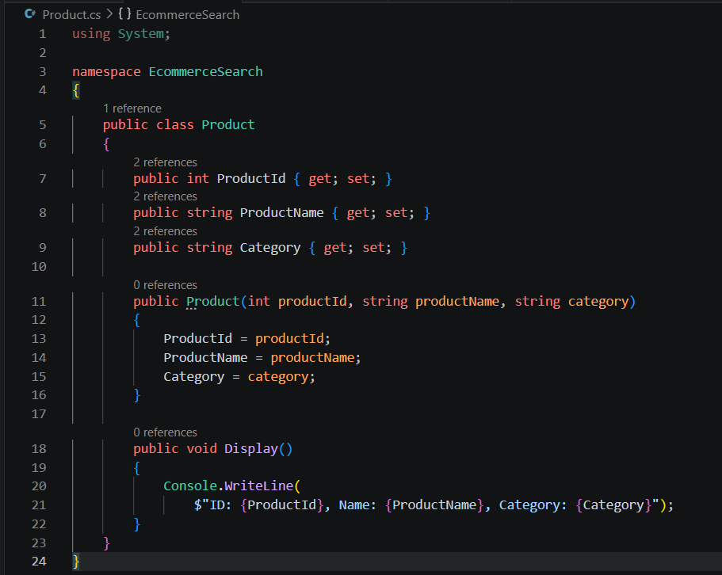

4. Search Operations(Linear Search and Binary Search)
SearchUtility.cs:
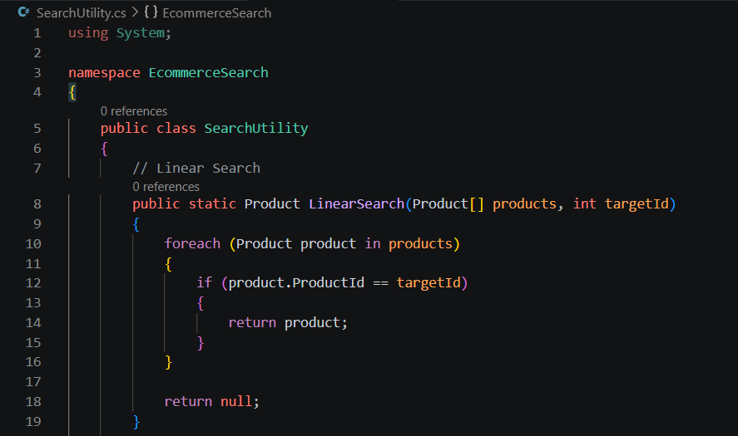
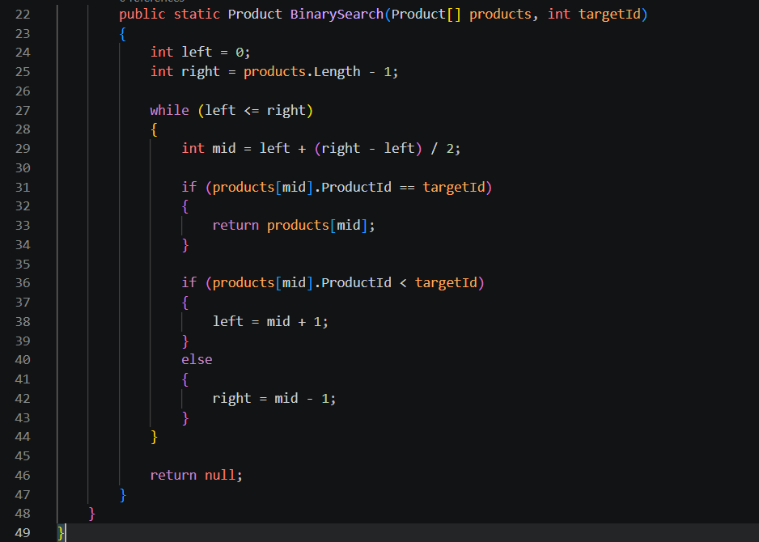

5. Test Program (Program.cs):
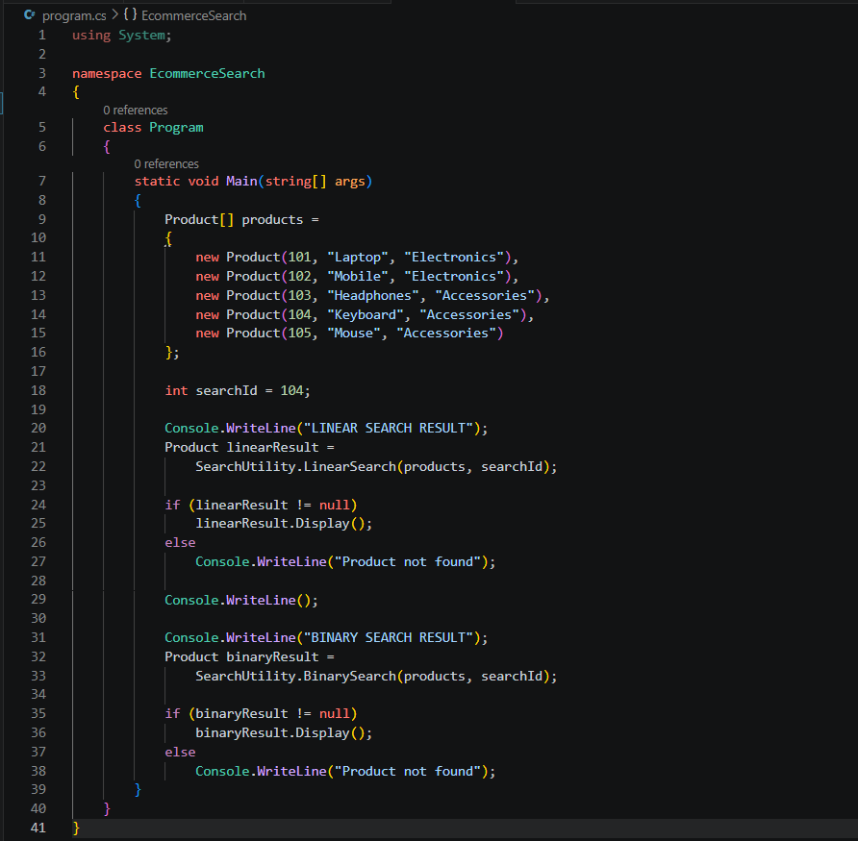
Output:
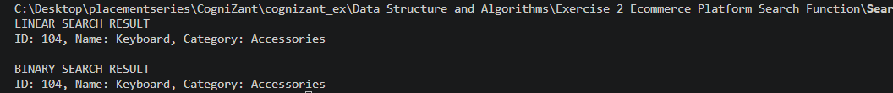

6. Complexity Analysis
Algorithm | Best Case | Average Case | Worst Case
Linear Search | O(1) | O(n) | O(n)
Binary Search | O(1) | O(log n) | O(log n)

7. Conclusion
Binary Search is more suitable for an e-commerce platform because:
- Product databases can contain thousands or millions of records.
- Binary Search significantly reduces search time.
- It performs in O(log n) time compared to O(n) for Linear Search.
- The only requirement is that the products must be stored in a sorted order based on ProductId.
Therefore, for large-scale e-commerce applications, Binary Search is preferred over Linear Search for faster product retrieval.

